C++文本信息加密管理系统
- 程序功能:
1.文本增删查改
2.文本输入输出 使用二进制加密算法
3.菜单栏和功能栏交互

- UML:
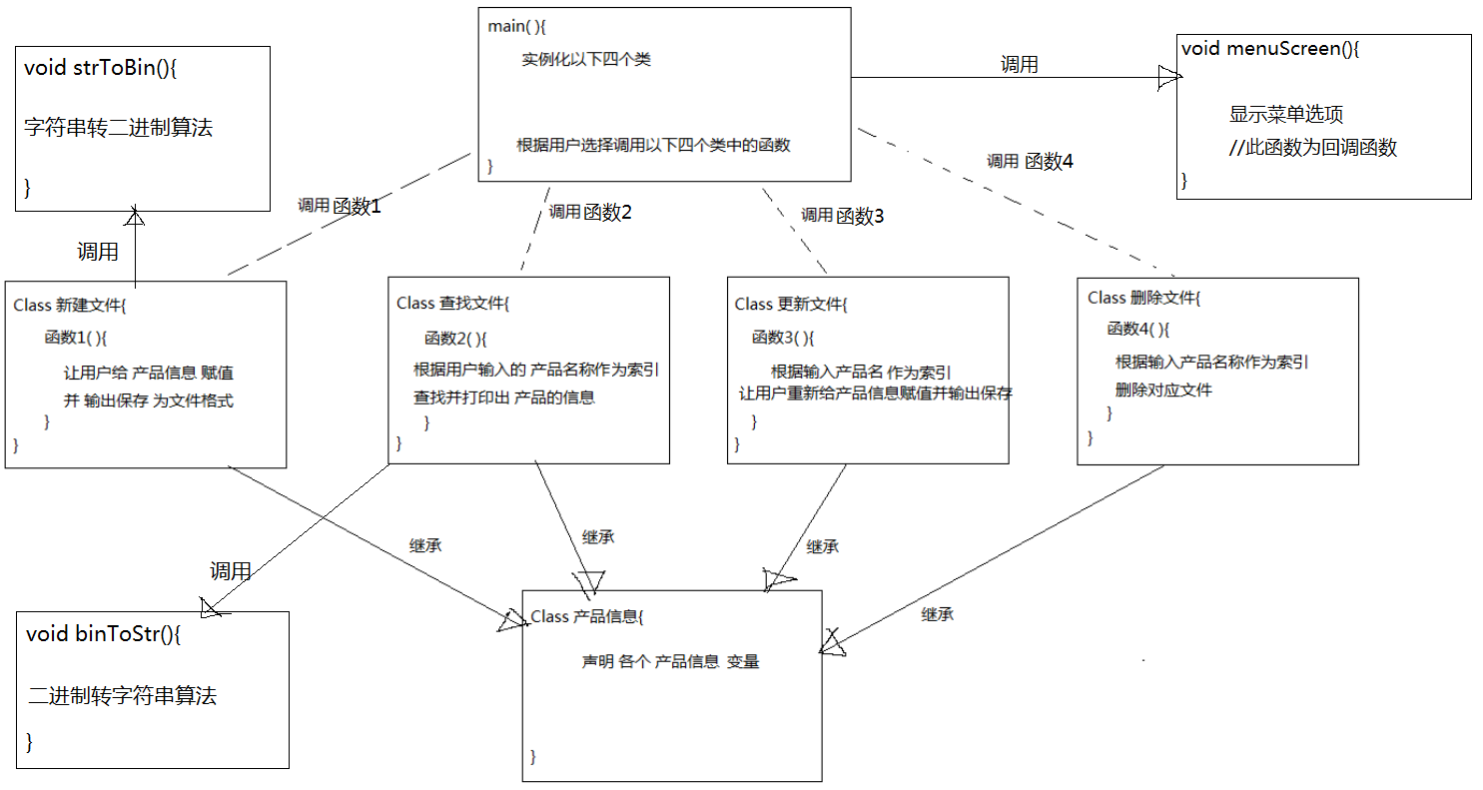

- 代码:
#include "stdafx.h"
#include <iostream>
#include <string>
#include <fstream>
#include <cstdlib>
#include <stdio.h>
#include <conio.h>
#include <bitset>
#include <sstream>
using namespace std;

class product_Information{
protected:
string Product_Name;
string Product_ID;
string Manufacture_date;
string price;
string Brand;
string Expiary_Date;
char confirmation;

string Product_Name_Bin;
string Product_ID_Bin;
string Manufacture_date_Bin;
string price_Bin;
string Brand_Bin;
string Expiary_Date_Bin;
};

string strToBin(string str){ //把字符串转换为二进制 然后输出到文本的算法
string storeStr;
for (int i = 0; i<str.length(); i++){
unsigned char k = 0x80;
for (int z = 0; z < 8; z++, k >>= 1){
if (str[i] & k){ //c AND k = 1 = true
storeStr += "1";
}
else{
storeStr += "0";
}
}
storeStr += " ";
}
return storeStr;
}

void binToStr(string fileName){ //把二进制转换为字符串 然后输出到控制台的算法
FILE *fptr;
#pragma warning(disable:4996) //supress the warning for fopen()
fptr = fopen(fileName.c_str(), "r");
char myline[9999];
while (!feof(fptr)){
fgets(myline, 9999, fptr);
istringstream in(myline);
bitset<8> bs;
while (in >> bs)
{
cout << char(bs.to_ulong());
}
cout << "\n";
}
fclose(fptr);
}

class add_Product :public product_Information{
public:

void function1(){
system("CLS");//CLS=clear string
cout << "\t\t\t\tADD FUNCTION" << endl;
cout << "\t\t\t-----------------------------" << endl;
while (confirmation != 'N'){
//让用户给变量赋值
cout << "please enter Product_Name" << endl;
cin >> Product_Name;
cout << "please enter Product_ID" << endl;
cin >> Product_ID;
cout << "please enter Manufacture_date" << endl;
cin >> Manufacture_date;
cout << "please enter price" << endl;
cin >> price;
cout << "please enter Brand" << endl;
cin >> Brand;
cout << "please enter Expiary_Date" << endl;
cin >> Expiary_Date;
cout << "\n";
cout << "Confirm add this stock?(Y/N)" << endl;
cin >> confirmation;
if (confirmation == 'Y'){
//调用stringToBinary函数
ofstream outputFile(Product_Name);
outputFile << strToBin("Product_Name : ") << strToBin(Product_Name) << endl;
outputFile << strToBin("Product_ID : ") << strToBin(Product_ID) << endl;
outputFile << strToBin("Manufacture_date : ") << strToBin(Manufacture_date) << endl;
outputFile << strToBin("price : ") << strToBin(price) << endl;
outputFile << strToBin("Brand : ") << strToBin(Brand) << endl;
outputFile << strToBin("Expiary_Date : ") << strToBin(Expiary_Date) << endl;
cout << "\n";
cout << "File is added to the Same Directory as this cpp file" << endl;
cout << "\n";
cout << "Add another file?(Y/N)" << endl;
cin >> confirmation;
}
else
{
cout << "\n";
cout << "add_Product Failed" << endl;
cout << "\n";
cout << "Add another file?(Y/N)" << endl;
cin >> confirmation;
}
}
}
};

class search_Product :public product_Information{
public:

void function2(){
system("CLS");//CLS=clear string
cout << "\t\t\t\tSEARCH FUNCTION" << endl;
cout << "\t\t\t-----------------------------" << endl;
while (confirmation != 'N'){
cout << "please enter Product_Name" << endl;
cin >> Product_Name;
//根据输入索引打印文件内容
ifstream inputFile;
inputFile.open(Product_Name);//打开文件
if (inputFile.is_open()){
cout << "\n";
binToStr(Product_Name);
cout << "\n";
}
else{
cout << "\n";
cout << "File " << Product_Name <<" is not found" << endl;
}
cout << "\n";
cout << "Search Again?(Y/N)" << endl;
cin >> confirmation;
}
}
};

class edit_Product :public product_Information{
char changeConfirmation;
public:
void function3(){ //无法实现用户指定修改，只能让用户全部重新输入
system("CLS");//CLS=clear string
cout << "\t\t\t\tEDIT FUNCTION" << endl;
cout << "\t\t\t-----------------------------" << endl;
while (confirmation != 'N'){
cout << "please enter Product_Name you want to update" << endl;
cin >> Product_Name;
//根据输入索引打印文件内容
ifstream inputFile;
inputFile.open(Product_Name);//打开文件
if (inputFile.is_open()){
cout << "please enter the new Product_ID" << endl;
cin >> Product_ID;
cout << "please enter the new Manufacture_date" << endl;
cin >> Manufacture_date;
cout << "please enter the new price" << endl;
cin >> price;
cout << "please enter the new Brand" << endl;
cin >> Brand;
cout << "please enter the new Expiary_Date" << endl;
cin >> Expiary_Date;
cout << "Confirm change this stock?(Y/N)" << endl;
cin >> changeConfirmation;
if (changeConfirmation == 'Y'){
//输出变量到File Output
ofstream outputFile(Product_Name);
outputFile << strToBin("Product_Name : ") << strToBin(Product_Name) << endl;
outputFile << strToBin("Product_ID : ") << strToBin(Product_ID) << endl;
outputFile << strToBin("Manufacture_date : ") << strToBin(Manufacture_date) << endl;
outputFile << strToBin("price : ") << strToBin(price) << endl;
outputFile << strToBin("Brand : ") << strToBin(Brand) << endl;
outputFile << strToBin("Expiary_Date : ") << strToBin(Expiary_Date) << endl;
cout << "\n";
cout << "Change is made to file : " << Product_Name << endl;
cout << "\n";
cout << "Change another file?(Y/N)" << endl;
cin >> confirmation;
}
else
{
cout << "\n";
cout << "Change is not made to file : " << Product_Name << endl;
break;
}
}
else{
cout << "\n";
cout << "Error occured when opening file " << Product_Name << endl;
cout << "\n";
cout << "Search Again?(Y/N)" << endl;
cin >> confirmation;
}

}
}
};

class delete_Product :public product_Information{
public:
void function4(){
system("CLS");//CLS=clear string
cout << "\t\t\t\tDELETE FUNCTION" << endl;
cout << "\t\t\t-----------------------------" << endl;
while (confirmation != 'N'){
cout << "please enter Product_Name you want to delete" << endl;
cin >> Product_Name;
cout << "\n";
cout << "Do you confirm delete file " << Product_Name << " ? (Y for confirm)" << endl;
cin >> confirmation;
if (confirmation == 'Y'){
ifstream inputFile;
inputFile.open(Product_Name);//打开文件
if (inputFile.is_open()){
inputFile.close();
remove(Product_Name.c_str()); //.remove()的参数是char类型，不可以是string类型
cout << "\n";
cout << "File " << Product_Name << " removed" << endl;
}
else{
cout << "\n";
cout << "File " << Product_Name << "is not found" << endl;
}
}
else{
cout << "\n";
cout << "Change is not made to file : " << Product_Name << endl;
}
cout << "\n";
cout << "Delete another file?(Y/N)" << endl;
cin >> confirmation;
}
}
};

void menuScreen(){ //回调函数
system("CLS");//CLS=clear string
cout << "\t\t\t\tMAIN MENU" << endl;
cout << "\t\t\t-----------------------------" << endl;
int functionChoose = 0;
add_Product myAdd;
search_Product mySearch;
edit_Product myEdit;
delete_Product myDelete;
cout << "\n";
cout << "\tChoose Function number 1 to 4 :" << endl;
cout << "\t******************************************************" << endl;
cout << "\t* Enter 1 ---> Create a new product description file *" << endl;
cout << "\t* Enter 2 ---> Search for a product description *" << endl;
cout << "\t* Enter 3 ---> Update a product description file *" << endl;
cout << "\t* Enter 4 ---> Delete a product description file *" << endl;
cout << "\t* Enter 5 ---> Quit program *" << endl;
cout << "\t******************************************************" << endl;
cin >> functionChoose;
while (functionChoose != 1 || 2 || 3 || 4 || 5){
if (functionChoose == 1){
myAdd.function1();
menuScreen(); //回调
return;
}
else if (functionChoose == 2){
mySearch.function2();
menuScreen();
return;
}
else if (functionChoose == 3){
myEdit.function3();
menuScreen();
return;
}
else if (functionChoose == 4){
myDelete.function4();
menuScreen();
return;
}
else if (functionChoose == 5){
return;
}
else
{
cin.clear();//cin.clear()和cin.sync()连用的作用是 清除缓存区中上一次cin的输入值，
cin.sync();//否则如果有人 输入超出int范围的数，这里会进入无限循环
cout << "Invalid input Please select again" << endl;
cin >> functionChoose;//重新cin值
}
}
}

void main()
{
menuScreen();
cout << "\n";
cout << "\t\t***********************************" << endl;
cout << "\t\t* Thank you for using this system *" << endl;
cout << "\t\t* Good day *" << endl;
cout << "\t\t***********************************" << endl;
cout << "\n";
system("pause");
}

